**Precondition:**

1) Machine should already have Eclipse / IntelliJ IDE installed.

2) Machine should already have Git installed (<https://git-scm.com/download/win>)

To run all the test cases, simply follow the steps below

1. Import project to Eclipse / IntelliJ or any IDE from Github

(https://github.com/zhirks/currencyconverter)

1. Run test project using **TestRunner.xml**. Edit the tests to be executed in class tags.

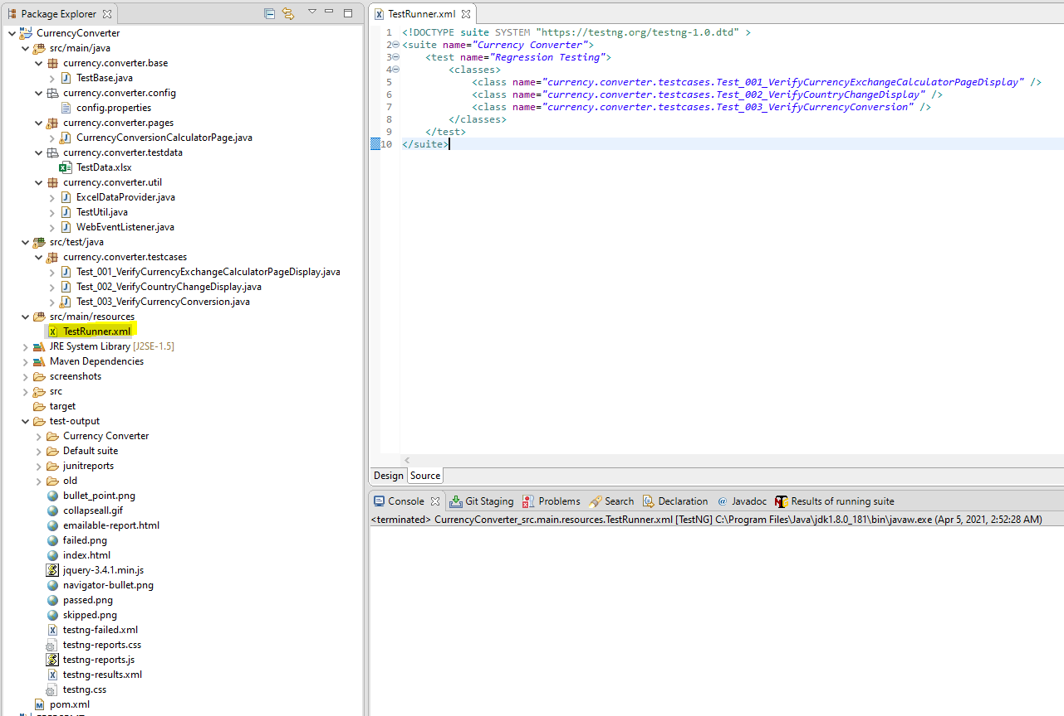

1. To run the above settings, right click **TestRunner.xml** > **Run As** >**TestNG Suite**

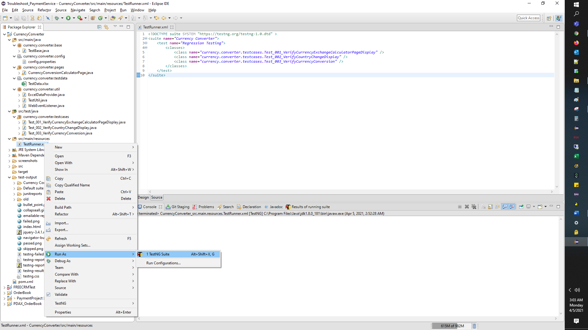

1. Results can be viewed in Console tab of Eclipse

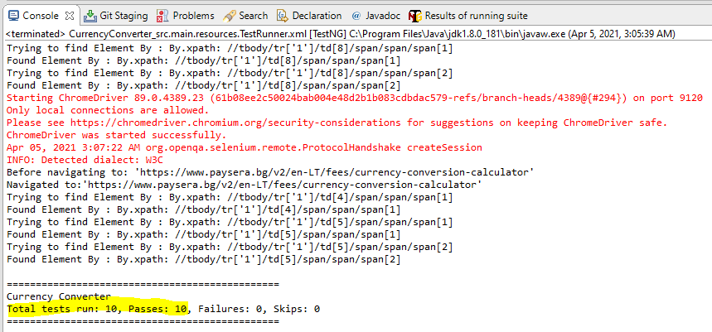

You may also see emailable report format here

Right click **emailable-report.html**, go to Properties and get the file location

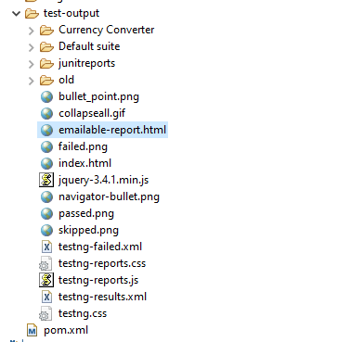

Open it in your local browser

